Using File Descriptors

1) Try to append few lines to a file test.txt using file descriptor.

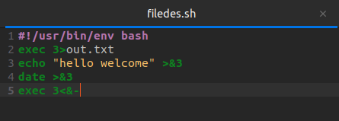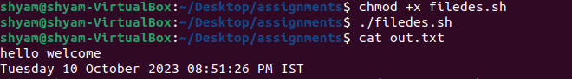

2) Display the content of the file using file descriptor.

